**Electrical & Mechanical Engineering – Challenges and Solutions**

**Challenge**

The biggest challenge in this project is achieving a 5.8Hz frequency without hindering the required amplitude. This frequency is very low and not many off the shelf motors can provide such a low frequency. To tackle this challenge, the Electrical division of the team has the following three concepts in mind. This involves a test phase and based on the success rate either option will be selected.

1. Low Frequency Portable Shaker Table
2. Testing with a simple motor and plywood plank
3. PWM – Pulse Width Modulation

Figure : Low Frequency Portable Shaker Table [1]

**Low Frequency Portable Shaker Table**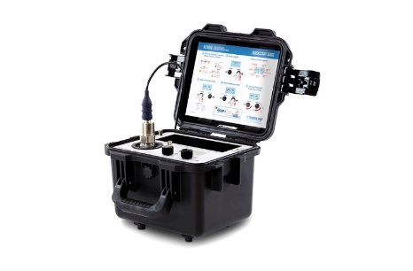The low frequency portable shaker table provided by the Modal Shop is the world’s first and only ISO 17025 accredited shaker table that can vibrate with a low frequency such as 0.7Hz. The range extends all the way up to 2kHz. The accuracy is assured to +/- 3% by the vendor. This equipment would be the most suitable for the project as desired frequency can be achieved and it already consist of the shaker table. However, the goal was to dissect the equipment after purchasing and obtain the main components from it such as the motor that drives the frequency.

Every product comes with its own pros and cons. The advantage of using this equipment is the solution to our project is pre-done and there is less work to be done as the desired frequency can be achieved. However, the con is the price factor. The price of the equipment is way over the budget so unfortunately, there is less chances of moving forward with the low frequency shaker table. The vendor has agreed for a free demonstration at campus in order to help us resolve the current issue of achieving the low frequency required by explaining the science behind the device [1].

[1] “Low frequency portable Shaker Table: 9200D,” *The Modal Shop*. [Online]. Available:  
https://www.modalshop.com/industrial-vibration/products/portable-shaker-tables/9200D-low-frequency-calibrator. [Accessed: 21-Sep-2022].

**Testing with a simple motor and plywood plank**

The approach is simple and straightforward, but results obtained might heavily impact the project concept in either a positive or negative manner. The approach taken is use a simple off the shelf motor to mimic vertical vibrations on a plywood plank of wood by attaching them together. The objective is to gather data in regard to frequency, amplitude, the resonance frequency and dampening factor and assess the solution based on the data gathered. Multiple accelerometers will be used to collect data and by using more than one accelerometer we can ensure the accuracy of the data by conducting multiple tests for each variable and considering the average result obtained.

The advantage of this concept is its fairly simple and carries a low cost. But the disadvantage is the result of it could impact the project moving forward if the desired frequency cannot be achieved.

**PWM – Pulse Width Modulation**

In order to experiment PWM, a similar approach to testing a simple motor with a plywood plank will be used. In this case the motor has to be a DC motor. A DC motor consists of two parts. The stationary body of the motor known as the Stator and the inner part that rotates to produce movement is known as the Rotor/ Armature. PWM turns a digital signal into an analog signal by changing the timing of how long it stays on and off [2].

The benefit of integrating PWM into a DC motor is that power loss in the switching device is very low. By varying the DC voltage applied to the motor, power applied to the motor can be controlled. The advantage of integrating PWM is the amplitude of the motor voltage remains constant thus frequency is the only variable that varies.

The disadvantage of using PWM with a DC motor is the reduced operational time due to overheating. In order to combat that, the solution in place is if PWM with a DC motor is successful, buy few more DC motors that are identical to each other and design a circuit to sequence the DC motors operation by shutting down after a certain interval so the motor can cool down and be ready for operation once the next motor is ready to rest and cool down [2].

[2] W. Storr, “Pulse width modulation used for motor control,” *Basic Electronics Tutorials*, 03-Aug-2022. [Online]. Available: https://www.electronics-tutorials.ws/blog/pulse-width-modulation.html. [Accessed: 21-Sep-2022].